EPAG Round Three JS Scoring Criteria
Scoring the JS Warm up Exercise
The warm up exercise is divided into three parts consisting of reading comprehension, photo viewing and comprehension, and math.

Consider the following when scoring the JS warm up exercise:

Read carefully and see whether the girl has an appreciated level of understanding. Award her the allotted points if she is noted to have an appreciated level of understanding. Watch out for unexpected errors such as grammatical errors, not punctuating, miss spelling of words, etc. As we look out for girls with good or appreciated level of understanding in line with our JS selection criteria, be careful to observe these key things and ensure to minus few points from her for not meeting the above mentioned criteria.
Consider the following when awarding points to each answer.
- For instance, when a girl doesn’t provide full answer to a particular question, the full point should not be awarded to her. When you observe that a girl miss spell some words or does not properly construct a sentence, she is not also entitled to the full point allotted.

- For example, where a girl miss spells picture to be pacture or picture, award her 10 points instead of 12.5.

- Five (5) points should be deducted from an applicant/girl who doesn’t write her name and the name of her community. However, when a girl writes one of these instead of the two, half of 5 points (2.5) should be deducted from her.
The reading comprehension session is divided into two parts:

Question 1- 4: photo viewing and story comprehension
Each of the 4 questions in this session has a possible value of 12.5 points. This equals a total of 50 points.

Numeracy session:
Questions 5-8: mathematical session
Each of the 4 questions in this session has a possible value of 12.5 points. This equals a total of 50 points.

Total possible score = 100%

Determining who passed or failed after marking the papers.
The team will determine the passing mark by scaling the warm up exercise results using the following criteria.
- The team will consider half or 50% of the highest score/mark at a testing center to be a passing mark. Example, where the highest score/mark at a given testing center is 90%, any girl who scores 45% is considered passed.

JS Warm up Exercise
INSTRUCTIONS: There are three sections to complete: story reading and comprehension, photo view and documentation, and math. First, please read the story and view the picture below. Then answer the proceeding questions according to your understanding. Lastly, answer the four math questions.
NAME:
COMMUNITY:

Instructions:
Look at the picture and read the story below. Answer the proceeding questions. Write in full sentences.

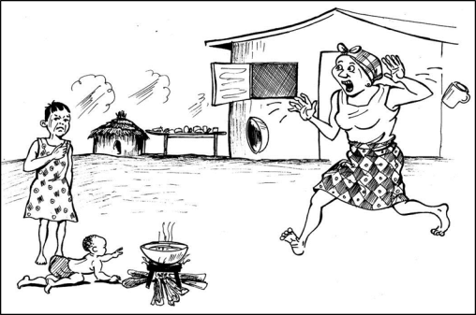
STORY: Fire Safety
Kebbeh’s mother is cooking. The water boils in the pan. The pan is on the fire. The fire is on the ground. “I have to go get four dishes,” says her mother. The mother goes in the house.

Kebbeh is outside with her baby sister. The baby is crawling around on the ground. Kebbeh is not minding the baby. The baby is too close to the fire! Kebbeh’s mother shouts. “Kebbeh! Get the baby!” Kebbeh frowns. Kebbeh’s mother runs out of the house to protect the baby from getting burned by the fire.

What is the story about?
___________________________________________________________________
___________________________________________________________________

- Why is Kebbeh’s mother vexed?
__________________________________________________________________
___________________________________________________________________

- Who is Kebbeh in this story?
___________________________________ ____________________________________________
____________________________________________

- Describe four things you can do to stop fire accidents from happening in your house and in your yard:
________________________________________________________________________________________________________________________________________________________________________________________________________
_______________________________________________________________________________________________________________________________________________________________________________________________________

5. 6.
7 3 5 7 3
- 5 4 + 2 4 2

7. 8.

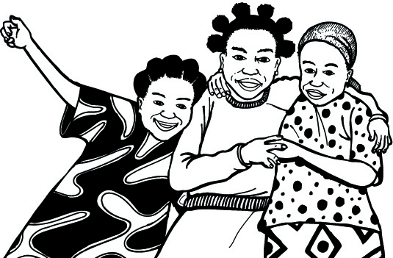
3 1 6 4 28
X 3

